| Google Classroom | Version: <1.0> |
| --- | --- |
| Use-case-Realization Specification: Complete Assignment | Date: <05/Dec/21> |
| <document identifier> | |

Revision History

| **Date** | **Version** | **Description** | **Author** |
| --- | --- | --- | --- |
| <05/Dec/21> | <1.0> | <Initial version> | Bui Hoang Quan |
| <06/Dec/21> | <1.1> | <Edited version> | Bui Hoang Quan |
|  |  |  |  |
|  |  |  |  |

**Google Classroom**

**Online Learning Platform**

**Use-Case Specification: <Archive Class>**

**Version 1.1**

# Manage Profile

## Brief Description:

* This use-case allows users to archive google classroom
* Subject: Teachers
* Purpose: Make it easier to manage multiple classes at a time and hide older classes.

# Flow of Event

## Basic Flow

* At the main page of Google Classroom,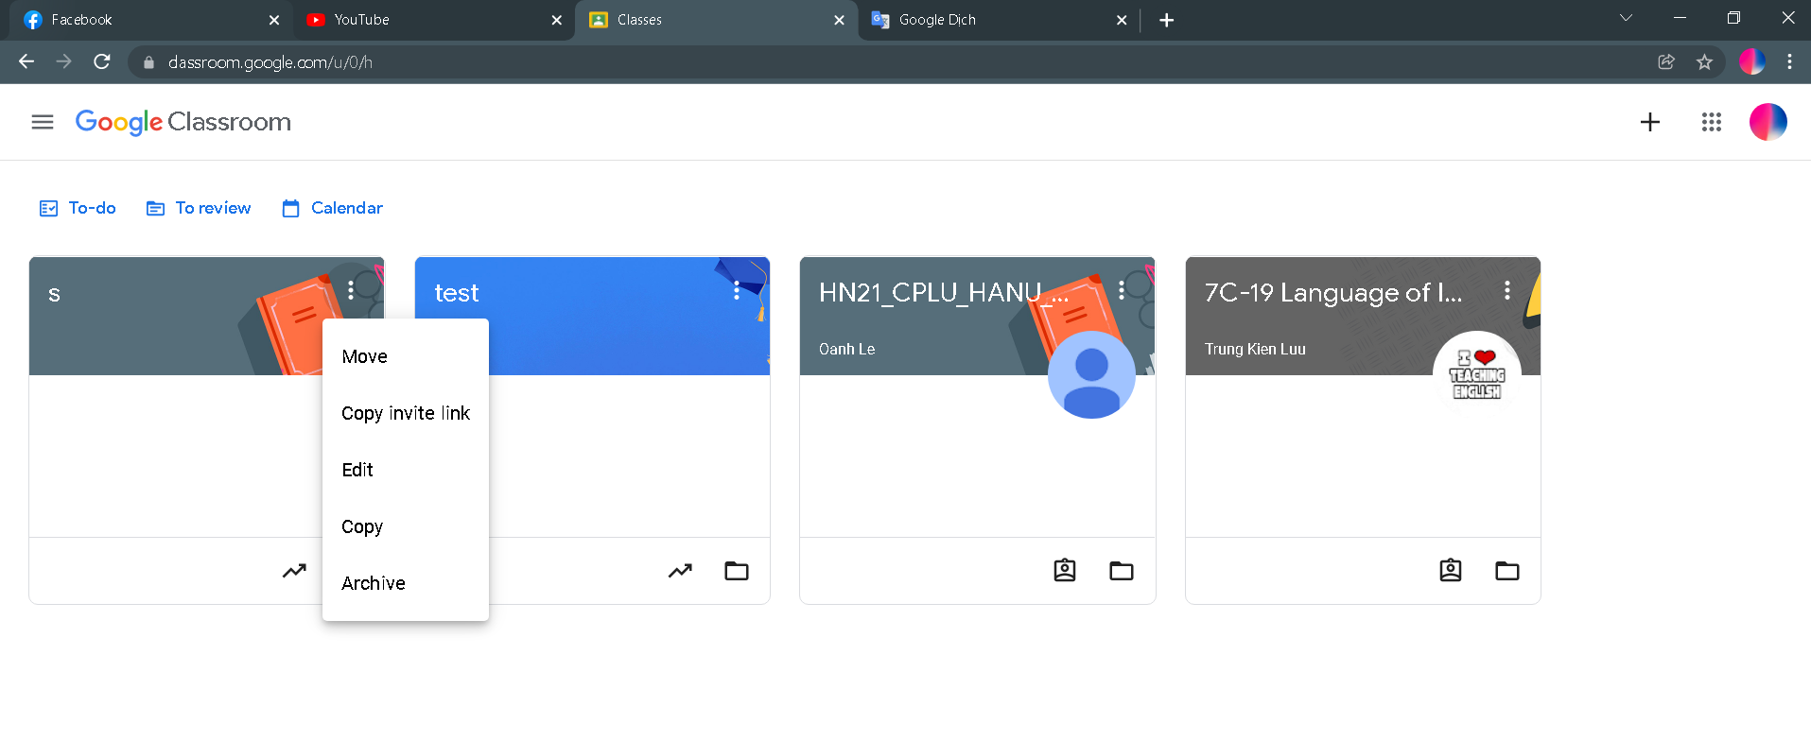decide which class to archive by choosing their cover, next click on the edit button which has a slight shadow effect when hovering the mouse. Then a small popup appears and gives users 5 options: “Move”, “Copy invite link”, “Edit”, “Copy” and our use case “Archive”.
* Hovering all the options with the mouse will have a slight shadow effect, lets click on the “Archive” button. A popup should appear like this 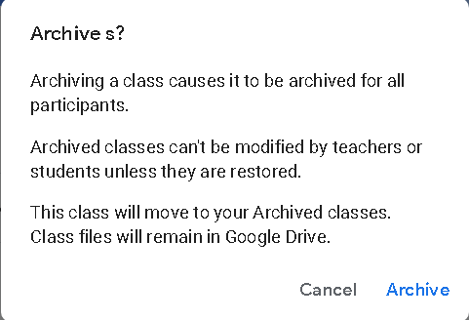

to tell you about the user’s permission after archiving a class. There are 2 buttons at the bottom “Cancel” and “Archive”, clicking on the “Cancel” button will return you to the main screen while the other button will also return you to the main screen but now the class you chose before is archived.

* To access to where all the classes archived, on the main screen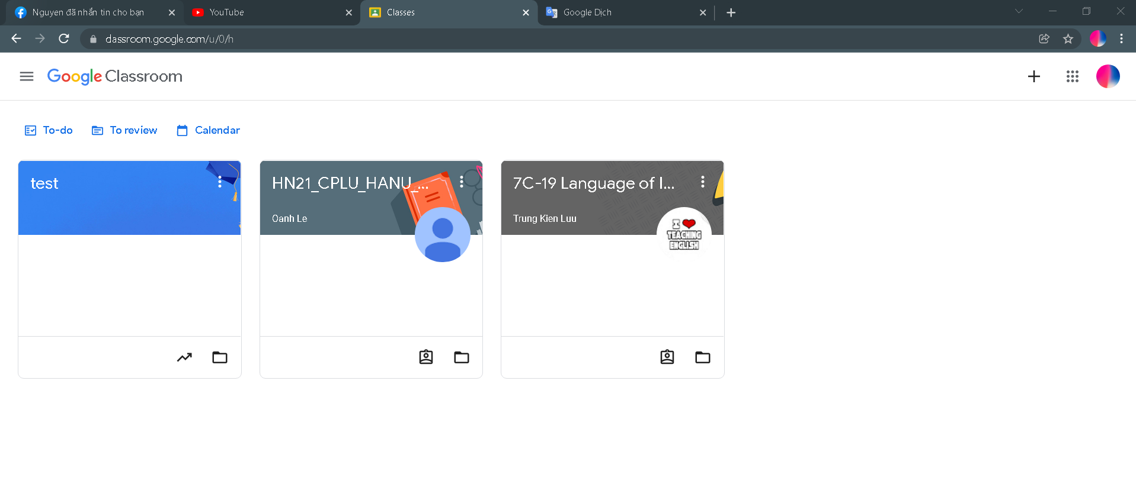we click on the button on the top right corner. It then should displays like this 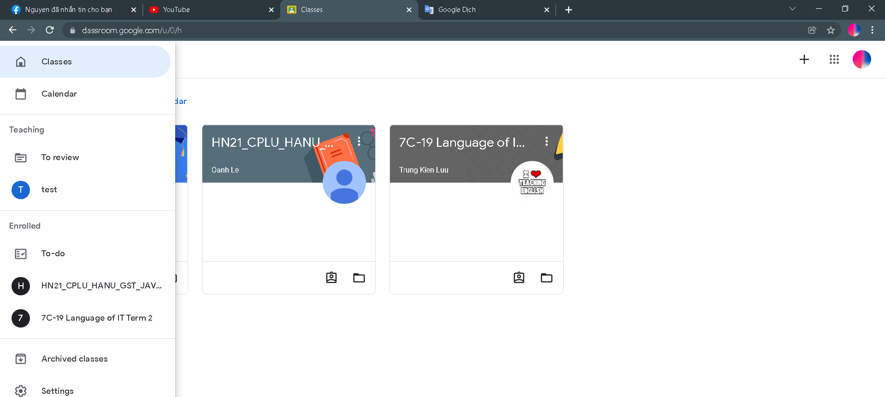 at the menu on the left side, click on the second option from the bottom name “Archived classes” (a slight shadow effect will appear while hovering the mouse on it) and we will be moved to the Archived class page like this 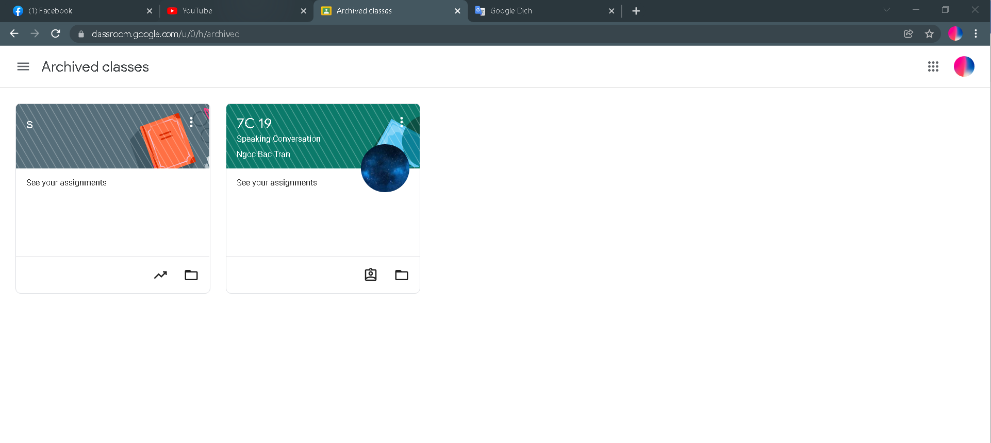 Now we can see all the classes that we archived before.